2 Peter 3

Main: The reality of the Second Coming, the temporality of this world, and the eternality of our new home should cause us grow.
He is no fool who gives what he cannot keep to gain that which he cannot lose

1. The mistakes made by those who scoff 3:1-9
They ignore the flood

They ignore His perspective on time

They ignore His heart and His purposes

2. The Day of the Lord and the Day of God 3:10-13
All that we know burns

How should we then live?

Something better is coming

3. Be careful, keep hope alive, and grow. 3:14-18

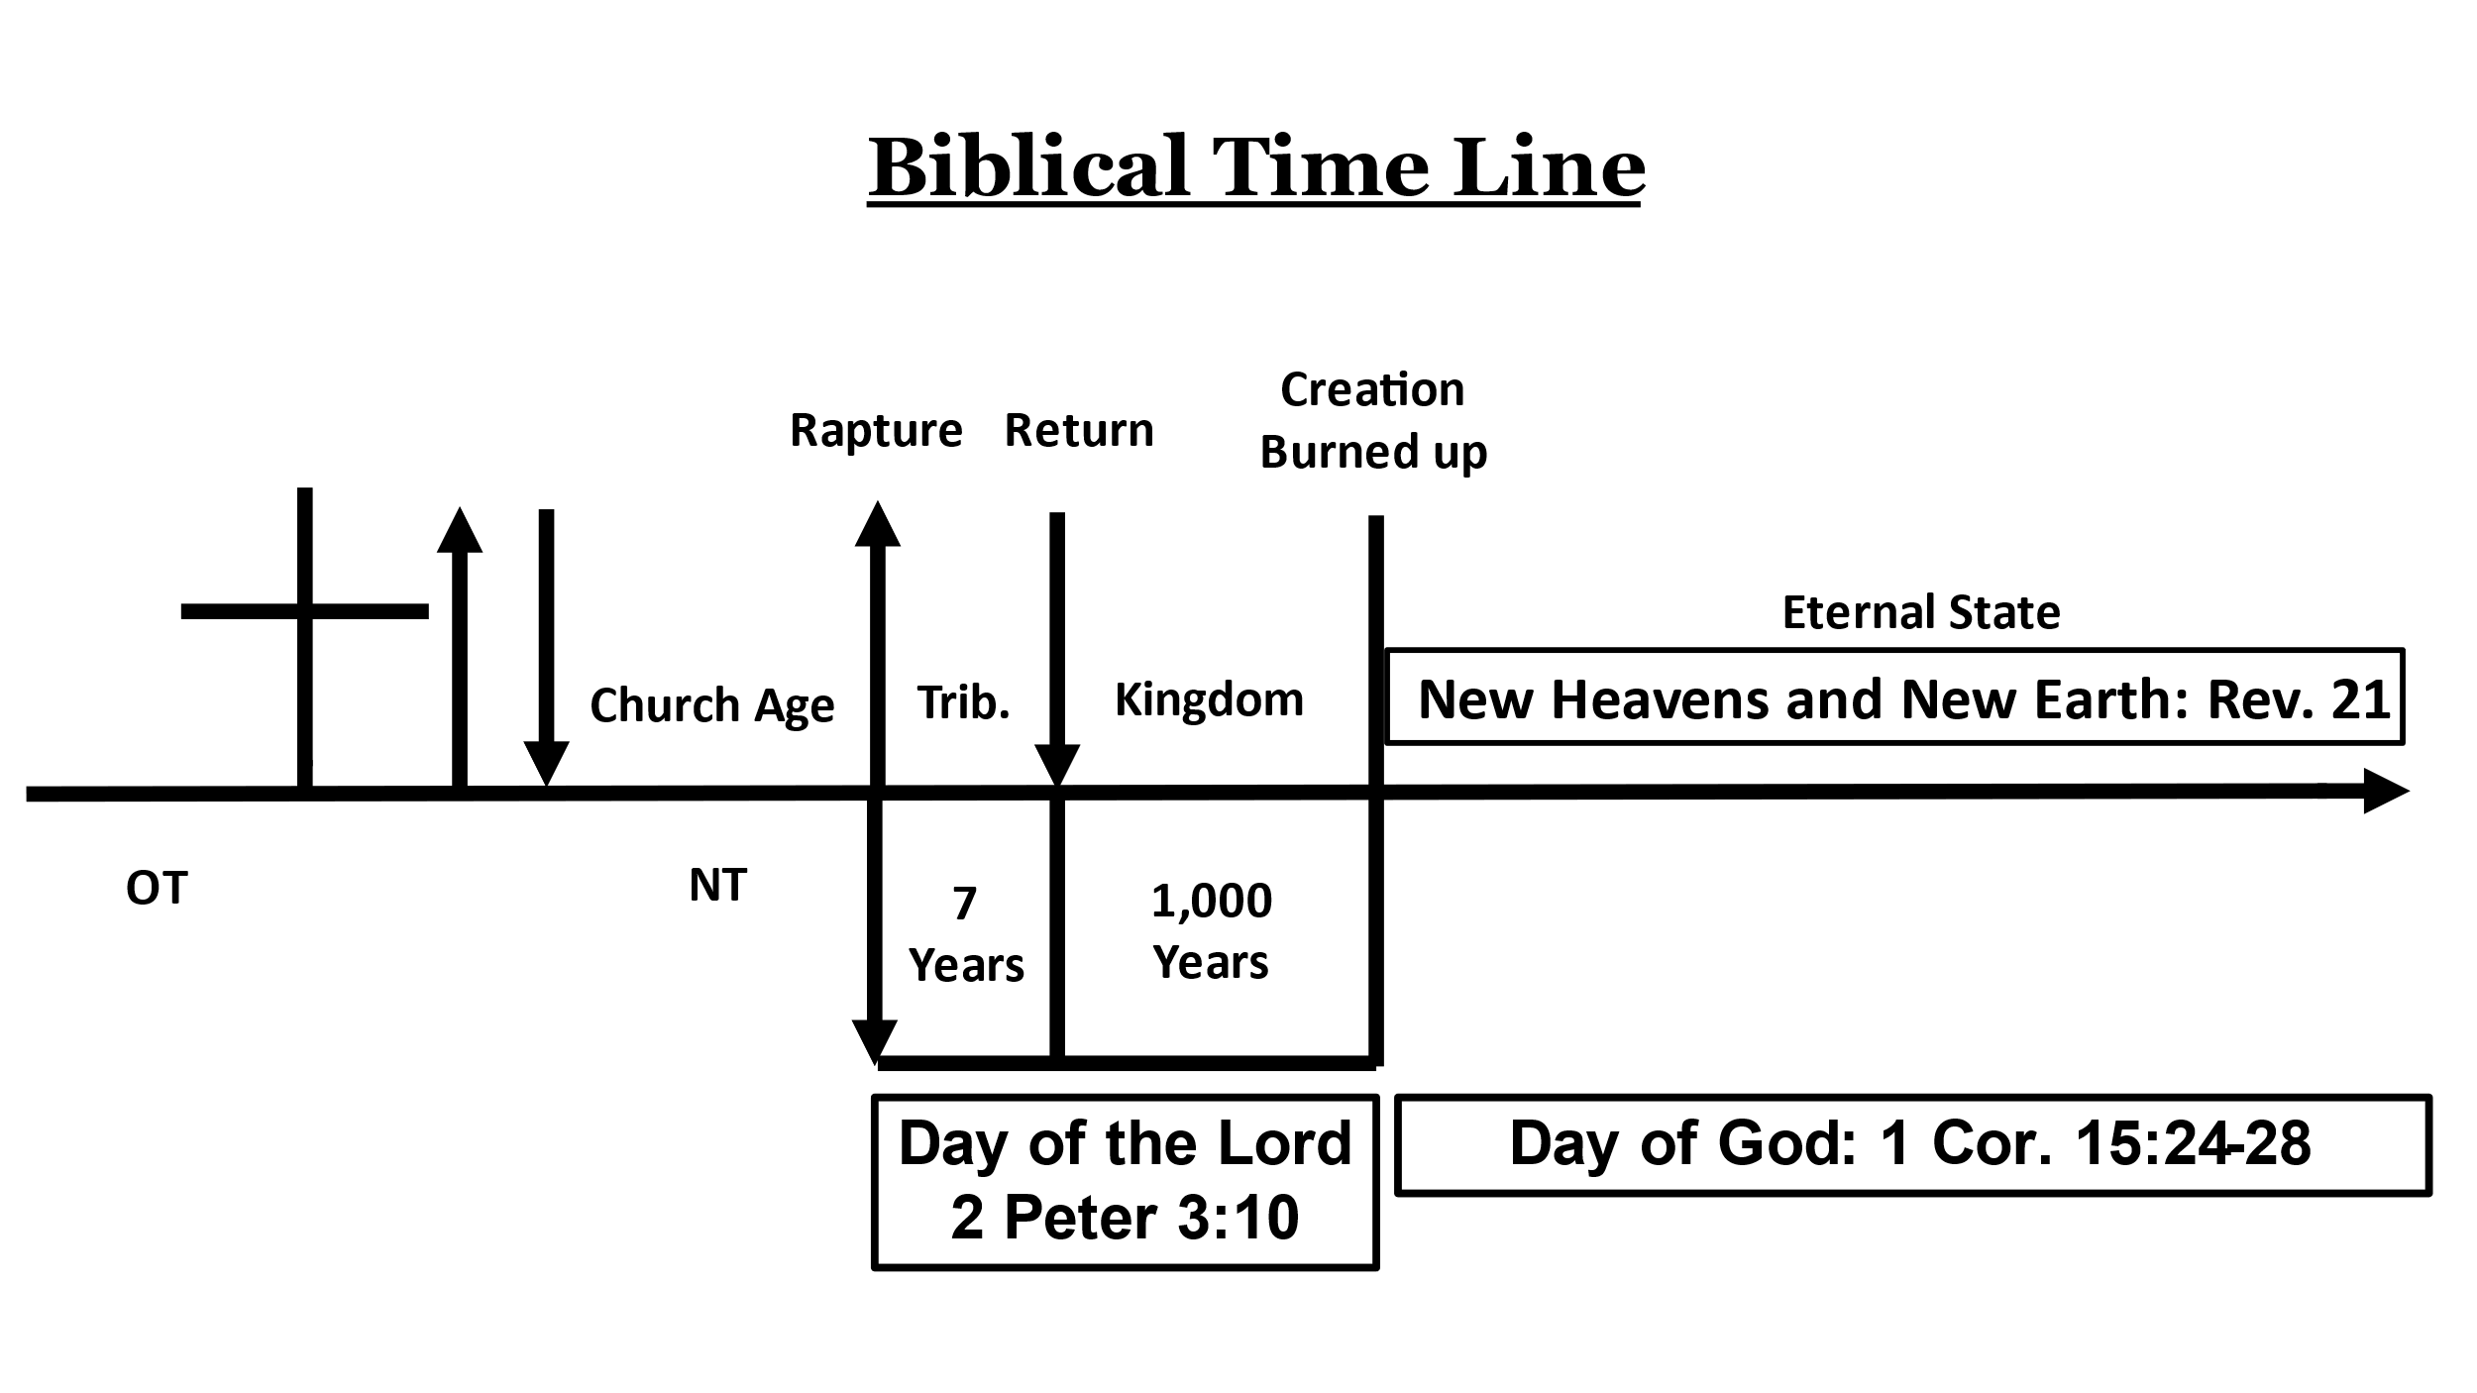
Some realities of the New Heavens and New Earth
1. It will be a literal place, similar to the Garden of Eden - Rev. 21:1; Ez. 36:35
2. God will live with us - Rev. 21:3
3. No one will ever be sad, cry, hurt, or die again - Rev. 21:4
4. Everything will be new. Everything bad is forever gone - Rev. 21:4-5
5. Even now, it is as good as done! - Rev. 21:6
6. Living there is free to anyone who wants it - Rev. 21:6
7. Those faithful to death, will reign as co-heirs with Jesus! Rev. 21:7: 2:25-27
8. The New Jerusalem is bright, beautiful, and massive - Rev. 21:10-11, 15-17
9. The city is made of gold, precious stones, and jewels – Rev. 21:18-21
10. There is no night and the gates of the city are never closed – Rev. 21:23, 25
11. Many nations there that bring tribute to the Lord and co-heirs may help rule
them – Rev. 21:26; 2 Tim. 2:12; Rev. 2:25-27
12. Faithful believers identified by white garments, crowns, special names,
markings, and other rewards – Rev. 2:7, 17; 3:4-5; 19:8
13. We will serve Jesus in the NJ – Rev. 22:3

