Daniel 8: Where have we seen this man before?
God allows evil to build as the world in rebellion gets what they want. The world will experience a time of evil, but it will be broken by the Most-High.
Summary: Chapters 7 and 8 focus on these things:
1) Kingdoms and rulers that are future to Daniel, both near and distant futures
Each of these kingdoms mentioned take parts of previous kingdoms. In that sense, they resemble one another and build on one another.
2) The eternal kingdom of the Lord Jesus Christ, emphasizing the distant future.
3) The coming evil world ruler
- Chapter 7 focuses on the kingdom he is associated with.
- Chapter 8 focuses on an evil, near-future king the future ruler resembles
- The future world ruler will be defeated, just like his earlier counterpart.
THE TEXT

1. The Vision 8:1-2

2. The Ram with Two Horns 8:3-4

3. The Male Goat from the West 8:5-7

4. The Large Horn is Broken 8:8

5. The Growing Power of the Little Horn 8:9-10 (Antiochus Epiphanes)

6. The Sanctuary defiled 8:11-14

7. Gabriel’s interpretation of the Ram and the Goat 8:15-22

8. Interpretation: The distant future and the coming world ruler 8:23-26

9. Daniel’s reaction 8:27

Ch. 7: Daniel begins to focus on the person and career of a coming world ruler.
- A prophecy of a future both near and far to Daniel.
- Four great kingdoms will come. The fourth kingdom is different.
- Ten kings will come out of this kingdom.
- From which kingdom comes another king different than the others.
  - He comes after the ten kings – 8
  - He uproots three of the ten kings - 8
  - He will be intelligent (eyes like a man) - 8
  - He will be arrogant and boastful – 11 (2 Thess. 2:4)
  - He will persecute the saints for 3 ½ years – 21, 25
  - He will overcome Israel – 21
  - He will be judged by God - 22
  - He will oppose God’s authority – 25
  - He will introduce an entirely new era, changing laws and instituting His own system – 25
  - He will be destroyed with his kingdom - 26
- The Fourth Kingdom will be destroyed by the “rock”
- The Son of Man will rule an eternal kingdom
- He will share it with His saints.

Ch. 8: Focus on a near-future ruler, Antiochus Epiphanes, and a distant future ruler. This the coming world ruler:
(From Pentecost in the Bible Knowledge Commentary)
- Will achieve great power by subduing others 24
- Will rise to power by promising false security 25
- Will be intelligent and persuasive 23
- Will be controlled by another (v. 24), that is Satan.
- Will be an adversary of Israel and subjugate Israel to his authority 24-25
- Will rise in opposition to the Prince of princes, the Lord Jesus Christ 25
- Will see his rule terminated by divine judgment 25
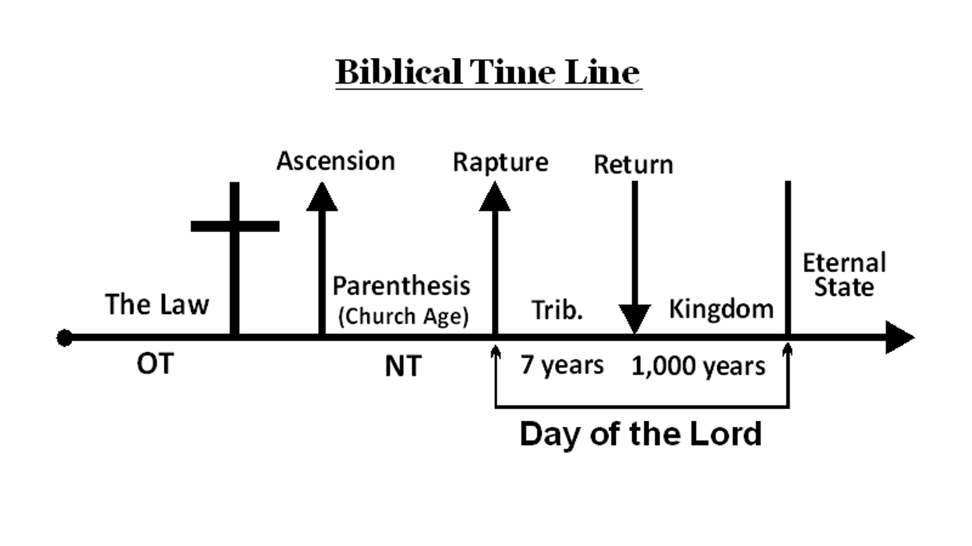

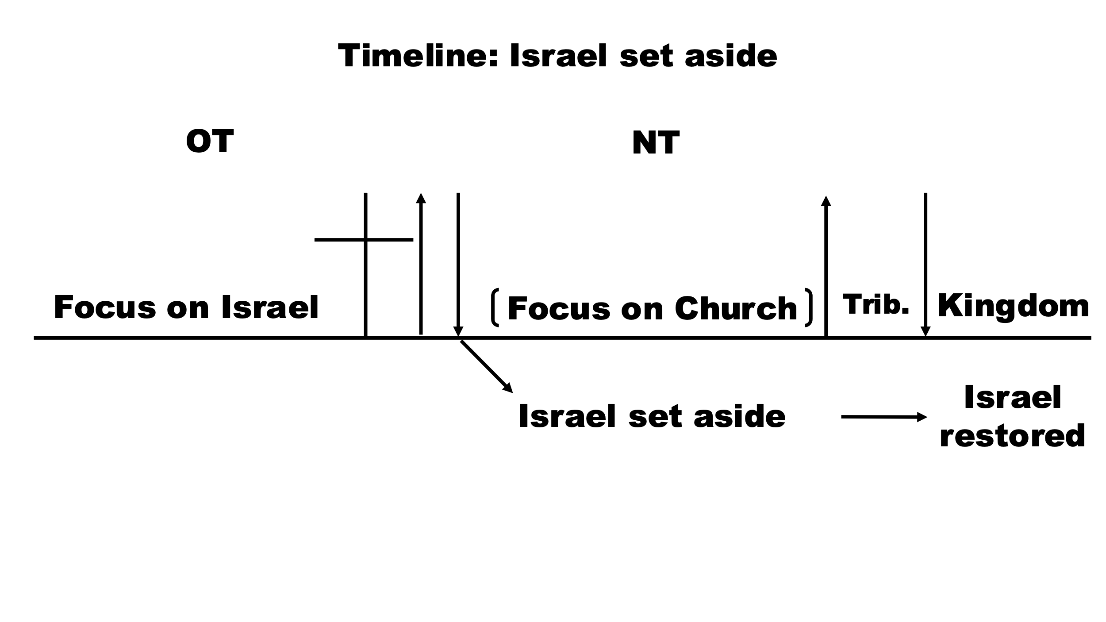

Overview of the Book of the Revelation

