Summary: The God who controlled the future then, controls the future now
The rule of God has been challenged. Israel is in captivity. And, Daniel uses the first seven chapters to make clear that the Most-High still rules by humbling Babylon’s rulers. The final chapters present the course of Israel’s history when another ruler challenges the sovereignty of God. He, too, will find that the Most-High rules in the kingdom of men and He gives it to whomever He wishes
2 Peter 1:20 – No prophetic scripture is not to be understood simply by its own interpretation, but in connection with others.

Daniel 1: Introducing Daniel

Daniel 2-7: The humiliation of the kings of Babylon

Daniel 2: Nebuchadnezzar’s vision: A sketch of prophetic history
Daniel 3: Punishment for worshipping the Lord: Fiery furnace
Daniel 4: Humiliation of Nebuchadnezzar
Daniel 5: Humiliation of Belshazzar
Daniel 6: Punishment for worshipping the Lord: Lion’s den
Daniel 7: Daniel’s vision: A sketch of prophetic history

Daniel 7-12: The humiliation of the king of the north

Ch. 7: Four great kingdoms and the little horn emerges from the fourth
- Daniel begins to focus on the person and career of a coming world ruler.
- A prophecy of a future both near and far to Daniel.
- Four great kingdoms will come. The fourth kingdom is different.
- Ten kings will come out of this kingdom.
- From which kingdom comes another king different than the others.
  - He uproots three of the ten kings – 8
  - He comes after the ten kings (not Nero!) – 8
  - He will be intelligent (eyes like a man) - 8
  - He will be arrogant and boastful – 11 (2 Thess. 2:4)
  - He will persecute the saints for 3 ½ years – 21, 25
  - He will overcome Israel – 21
  - He will be judged by God - 22
  - He will oppose and challenge God’s authority – 25
  - He will introduce an entirely new era, changing laws and instituting His own system – 25
  - He will be destroyed with his kingdom - 26
- The Fourth Kingdom will be destroyed by the “rock,” Messiah’s kingdom
- The Son of Man will rule an eternal kingdom
- He will share it with His saints.

Ch. 8: Focus on a near-future ruler and a distant-future ruler.
This distant-future (8:26) world ruler:
- Will achieve great power by subduing others 24
- Will rise to power by promising false security 25
- Will be intelligent and persuasive 23
- Will be controlled by another (v. 24), that is Satan.
- Will be an adversary of Israel and subjugate Israel to his authority 24-25
- Will rise in opposition to the Prince of princes, the Lord Jesus Christ 25
- Will see his rule terminated by divine judgment 25
(From “The Bible Knowledge Commentary,” Dr. Dwight Pentecost)

Chapter 9: The 70 Weeks, the Kingdom, the Messiah, and the coming world ruler
- 9:24 - Six conditions for Israel before the kingdom arrives
- 9:25 - 483 years from the command to restore and the coming of Messiah
- 9:26 – The death of the Messiah and the destruction of Jerusalem
- 9:27 – The seventieth week and the abomination by the Desolator
Chapter 10: The angelic Involvement in revelation and history
Chapter 11:1-35 – The rise of the prototype: Antiochus Epiphanes
- The stunningly accurate prophecy
- War between two powers and the assault on Israel
- Jesus makes clear that this “abomination” is not the last (Mt. 24:15-22)
- 34 verses specific and fulfilled, then information that is unfulfilled. Why? It involves another time; the God who controlled the future then…
Chapter 11:36-12:13 – The Great Tribulation and the End of the Age
- To date, there is no historical fulfillment of this information
- There are many intentional similarities, but no fulfillment
- “At that time” in 12:1; it deals with the time of 11:36-45
- 12:1-4 = Summary and conditions of the end
- 12:5-13 – The final 3 ½ years, the “breaking” of Israel, and the end
- This information matches what is found in many NT books
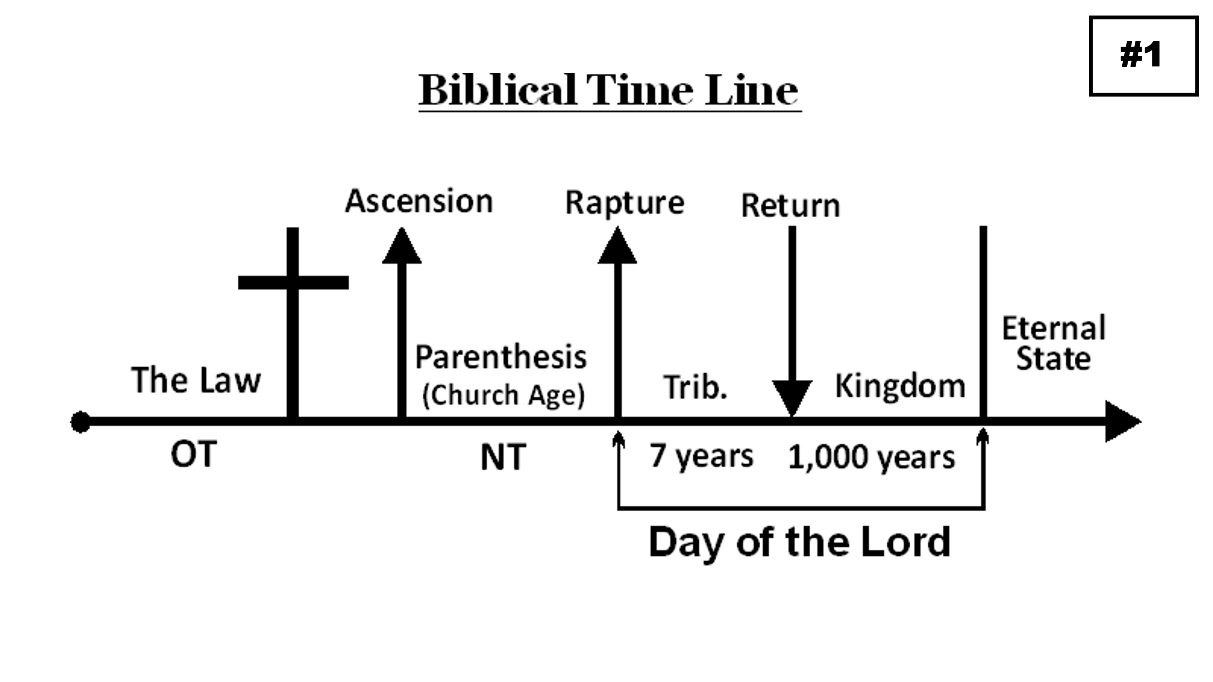

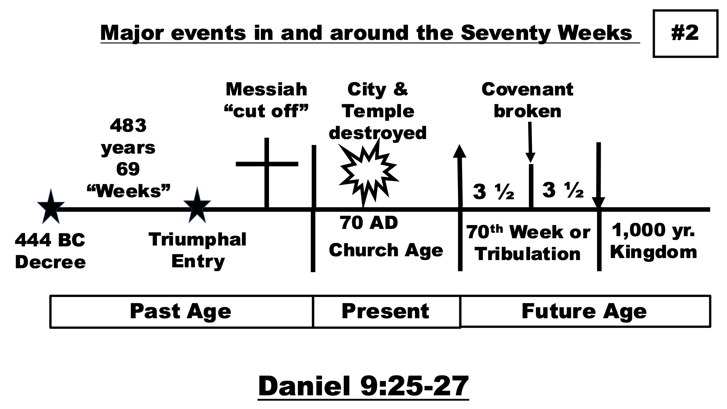

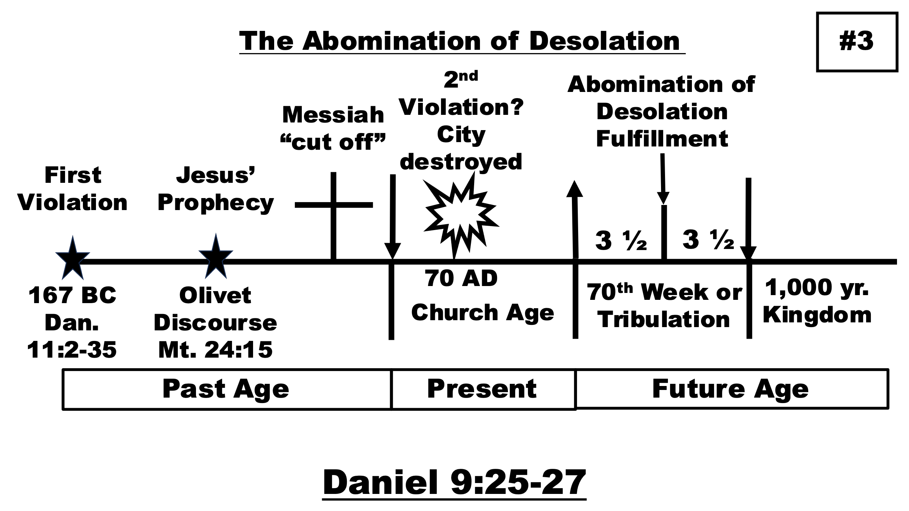

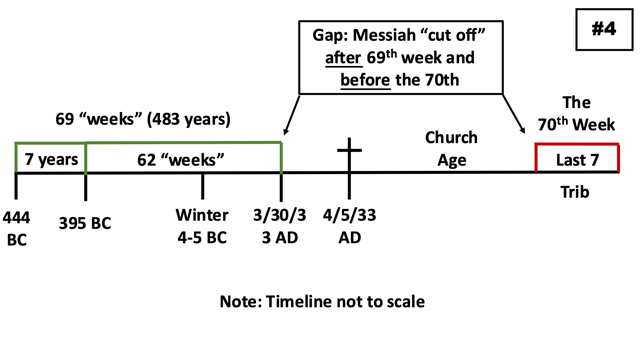

THE SETTING (10:1) Daniel 1:1
The third year of Jehoiakim 605 BC 1
Daniel 2:1 Neb’s second (accession) year 603–602 BC 2
Daniel 5:31 Darius conquered Babylon early 539 BC 5
Daniel 7:1 First year of Belshazzar 553 BC 3
Daniel 8:1 Third year of Belshazzar 551 BC 4
Daniel 9:1 First year of Darius late 539 BC 6
Daniel 10:1 Third year of Cyrus 536 BC 8
Daniel 11:1 First year of Darius late 539 B.C. 7

PERSIA: FOUR KEY KINGS (11:2)
These kings would follow Darius and Cyrus. The vision does not discuss weaker Persian kings.
1. Cambyses 529–522 B.C. (Not otherwise mentioned by the OT)
2. Pseudo-Smerdis 522–521 B.C. (Not otherwise mentioned by the OT)
3. Darius I Hystapses 521–486 B.C. (Ezra 5–6)
4. Xerxes I 486–465 B.C. (Ezra 4:6. Perhaps = King Ahasuerus of Esther 1)
Some conservatives delete Pseudo-Smyrdis and add Artaxerxes I as #4, but Artaxerxes I did not contend with Greece. He cannot be the fourth king.

GREECE: THE RISE AND FALL OF ALEXANDER: 356–323 B.C. (11:3-4)
Alexander
Cassander (Greece and Macedonia)
Lysimachus (Thrace, Bithynia, Asia Minor),
Ptolemy I Soter (Egypt) The first of the Ptolemies = King of the South
Seleucus I Nicator (Syria, Babylon) The first of the Seleucids = King of the North

EGYPT AND SYRIA: PERIOD 1: 323–246 B.C. (11:5-6)
Ptolemy I (325–285 B.C.), Seleucus I (312–281 B.C.), Berenice II = Ptolemy II’s daughter. Seleucus of Syria became stronger than Ptolemy of Egypt.
Ptolemy II of Egypt gave Berenice to Antiochus II of Syria. It did not end well. EGYPT AND SYRIA: PERIOD 2: 246–240 B.C. (11:7-9)
Ptolemy III of Egypt (246-221 bc) invaded Syria Seleucus II of Syria (246-225 bc) tried to invade Egypt. He fell off a horse and died.

EGYPT AND SYRIA: PERIOD 3: 223–187 B.C. (11:10-19)
Antiochus III of Syria (223-187 bc) at first could not penetrate Egypt at Raphia, but took Israel away from Egypt at Panias, then later (with help from Jews and Grecians) had successes.
He gave his daughter to Ptolemy V
Antiochus tried to take more land in Asia Minor and Greece, but Rome won at Thermophylae. He had to sign the Treaty of Apamea in 188 BC. He then attacked a temple of Bel in Elam in an effort to pay tribute demanded by Rome.

EGYPT AND SYRIA: PERIOD 4: 187–176 B.C. (11:20)
Seleucus IV raised taxes in an effort to pay tribute to Rome.

EGYPT AND SYRIA: PERIOD 5: 175–164 B.C. (11:21-35)
Antiochus IV Epiphanes (175-163 bc) usurped the throne from Demetrius Soter. (11:21)
He also deposed Onias III, the high priest in Jerusalem. (11:22)
He confiscated wealth from his enemies and redistributed it to his friends. (11:23-24)
Then he attacked Egypt at Pelusium (170 bc). Neither he nor Ptolemy Philometor (180-164, 163- 145 bc) kept the treaty (11:25-27). He carried spoils back to his capital, Antioch. On his way, he desecrated the Temple in Jerusalem. (11:28)
Antiochus attacked Egypt in 168 BC. While there, Gaius Pompillius Laenas met him. (11:29-30a)
167 BC: Antiochus returned to Jerusalem, made the Jewish religion illegal, sacrificed a pig on the altar, and erected a statue of Zeus in the Temple (11:30b-32)
Antiochus massacred pious Jews, Mattathias and his five sons began the Maccabean revolt (11:33-35)
Notes reproduced/edited from Dr. John Niemela; www.mol316.org

