1 Samuel 25
Main: A fool will not listen to the wise -OR-
What a fool believes; no wise man has the power to reason away
1 Samuel 25:1
Israel had been blessed for years through Samuel. Now, they will be blessed through David. The passing of the torch; Judges to Kings.

1 Samuel 25:2-3
Chapters 24 and 26 are mirror images of one another.
Sandwiched in-between is Ch. 25
One of the unifying themes is dealing with fools.
David stands out. But, so does Abigail.
Nabal, whose name means “fool’, is a wealthy man who stands in contrast to his wife, Abigail. However, he is much like Saul. Both are fools.
Abigail is clearly a woman of strength and commitment.

1 Samuel 25:4-9
6 Ryrie = “Say to him…live a long life”
8 A feast day – Celebrate prosperity = a pay day!
David’s approach to Nabal was understandable.
- He and his men had ensured Nabal would suffer no loss either of his animals nor his men.
- What David gave was much more than what he asked.

1 Samuel 25:10-11
Nabal’s said far more than, “No”.
- His words were very disrespectful and demeaning…and he knew it.
- It’s not a good idea to insult a man with a sword!
11 Nabal not only wouldn’t pay, he acted like he didn’t know David (he could have verified it with the men easily)

1 Samuel 25:12-13
David took the words as intended and saw them as a challenge to his integrity and honor.
- David also seemed to take them as a challenge to his manhood.
- Whatever the case, Nabal threw down and David took the challenge.

1 Samuel 25:14-31
14 (Ryrie) Reviled = Yelled at, screamed at
14 God may call us to suffer in marriage
Abigail’s brilliant words along with the brilliant manner in which she said them is a classic example of Proverbs 15:1 “A soft answer turns away wrath”
What a wise, godly woman! And, does David ever notice!
17 You simply can reason/talk with, some people
18 Abigail knew there was trouble
23 Abigail protects David from sin
25 A spouse can ruin you or protect you
29 (Ryrie) Could be translated “Should a man rise to pursue you and to seek your life, then the life of my lord shall be bound in the bundle of the living”
The figure is taken from the custom of binging valuables in a bundle to protect them from injury. God cares for his own as a man does his treasure.”
31 (Ryrie) “This isn’t a good idea for you”
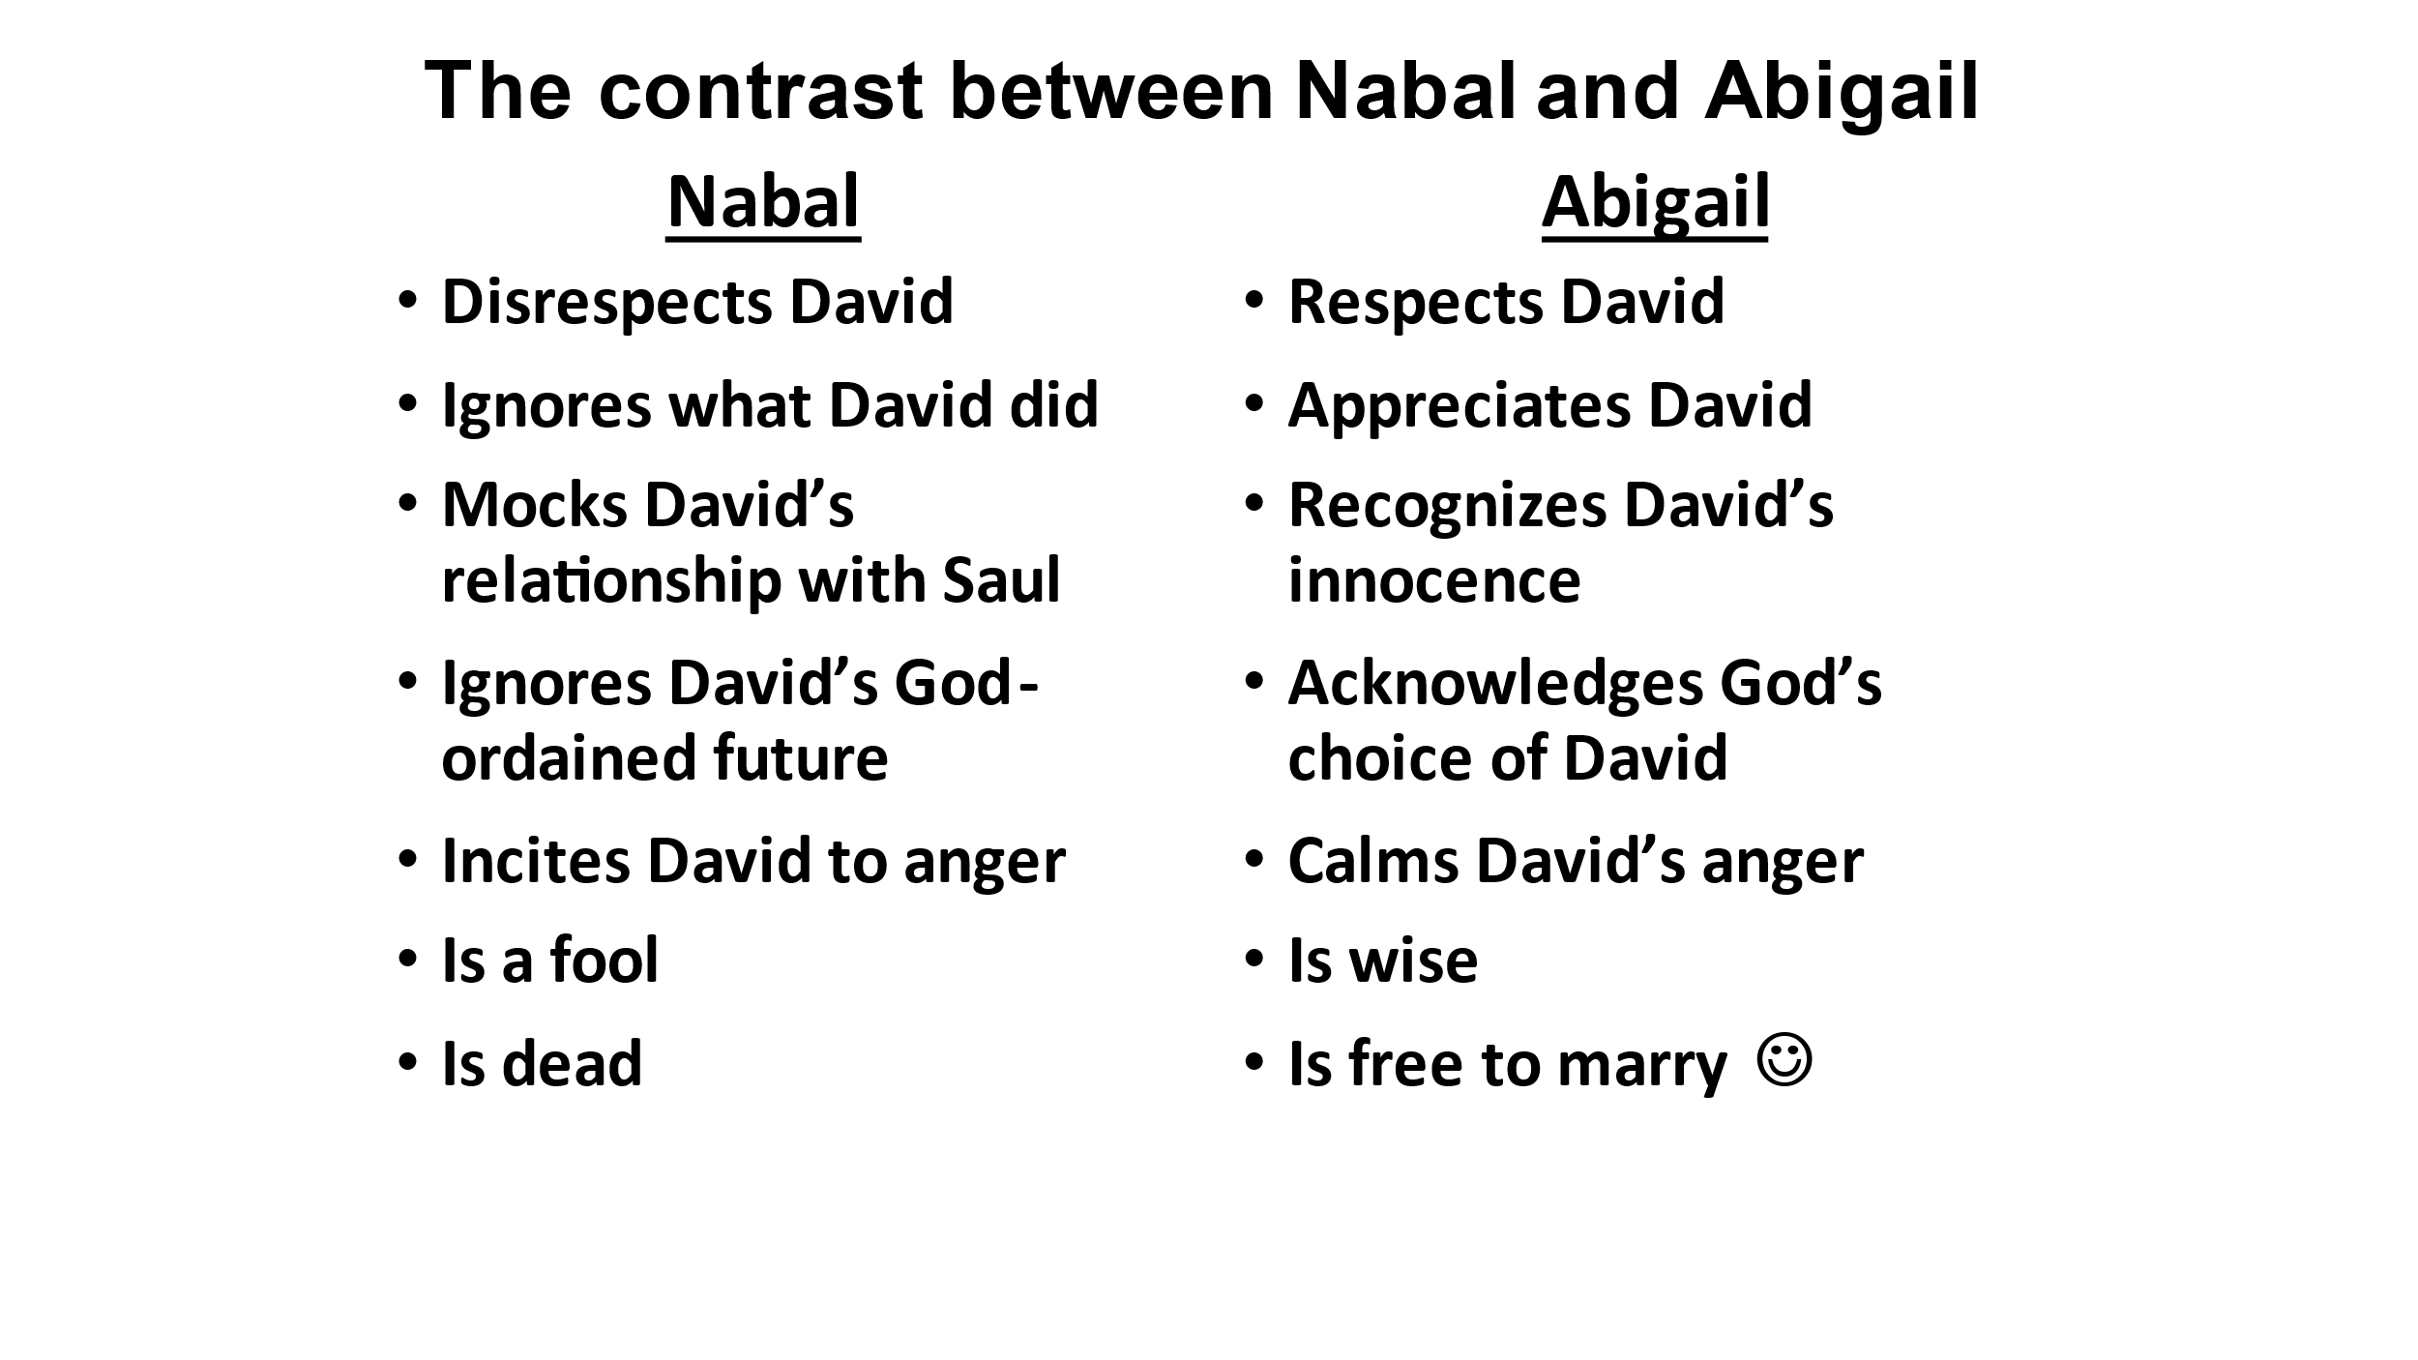
Our first response to our differences with our spouse should not be what might be the last response.
If we jump to the last response, we never give our spouses time to grow and fail to recognize our own set of issues we bring to the table - 1 Pet. 3:1-7

1 Samuel 25:32-37
Both what Abigail said and the way she presented herself and her words mattered.
We can learn a lot from Abigail about dealing with fools and those who act foolishly.
Abigail gave herself to God’s purposes.
- God vindicated her and also protected David through her wisdom.
37 Stroke = Paralyzed
Once again, God intends for David (and us!) to learn that vengeance is His and He will repay.
Forgiveness instead of paying people back for wrong is better because it:
- Obeys the Lord
- Honors the fact that it is God’s right
- Gives us the freedom that comes from forgiving
- Trusts that the Lord will properly take care of wrongs committed
Anger is simply not a better solution than forgiveness.
A person’s wisdom yields patience;
it is to one’s glory to overlook an offense.
Prov. 19:11
We must always remember the kind of people we are dealing with!
Answer a fool according to his folly lest he be wise in his own eyes;
Do not answer a fool according to his folly lest you be like him

Prov. 28:4-5
While we should never lower ourselves to the speech and lifestyle of a fool,
we should also seek to respond in a way that exposes to him his foolishness.

1 Samuel 25:38-44
38 Foolishness has its own reward
Just as the book opened, David now reverts to polygamy. There was absolutely no good reason for this. Why??
A lack of satisfaction causes many a heartache. Now, David acts like a fool.
43 Back to chapter one: Not a good idea

Proverbs 19:14
As great as David is, he also is human and his humanity is showing.
David’s problem with family in general and women in particular will haunt him throughout his life, as will his issues with vengeance.
No matter how spiritual, no matter how mature we become, we always have issues to address.
This should provoke us to humility and being wise enough to listen to the wise (9:12; 13:20)

